

**TRITLINGTON FIRST SCHOOL**

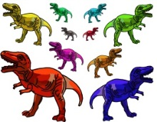**SPRING TERM HIGHLIGHTS**

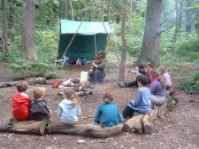The Spring Term began well and the children settled quickly into the New Year. As they enjoyed the topic of “Long, Long Ago”. Class 1 and EYFS researched Dinosaurs, drew and described these amazing creatures. Class 2 explored the eras of Prehistory.

We all enjoyed a Forest School Day, using the theme Long, Long Ago – we thought about survival and made dens, tracked trails and made soup!



White Rose Maths Open Morning……..We hope you enjoyed learning how we teach the maths, and the different ways children can look at numbers.



Class 2 have trained in gymnastics, and 6 children took part in the Morpeth Partnership Competition. They came fifth out of fourteen.

The whole school have enjoyed the company of Sam on Monday evening’s after school for our own Gymnastics club. Lots of laughter and lots of fun….as well as exercise.



WORLD BOOK DAY was celebrated in style. Thank you to all the parents who helped with their child’s costume…. They looked fantastic.



The Spring Term ended with the topic SUPER HEROES.

Class 1 and EYFS designed Super Heroes. Class 2 researched Heroic Vikings and amazing features of our planet.



BRITISH SCIENCE WEEK…………….All the classes enjoyed British Science Week. The theme was journeys, where the children made planes, helicopters, parachute, wheeled vehicles and pneumatic models! They even undertook Super Hero training in order to tackle all the tasks efficiently.



Thank you to everyone in class 1 and EYFS who have worked so hard with the pot plants and bulbs around school – they all look wonderful.

*Thank you for all your donations for the yard.*



Well Done…to our years 3 & 4’s for coming 7th in their recent Golf Festival



In Early Years …We had visits from tadpoles and lambs.

Did you see our new starters!!!

**Summer Term looking forward**

**Rain forests and**

**All Aboard for a Seaside adventure**

**Happy Easter**