DATE | SUBJECT | YEARS APPLIED TO | REFERENCE | REPLY  YES / NO
26.06.2019 | DATES / UPDATES FOR YOUR DIARIES | EVERYONE | SUMMER18 | NO

Dear Parents / Carers,

We are delighted to share an updated list of all the remaining activities for this term - it will be jam-packed as ever! Please keep an eye for letters with further details and permission slips where appropriate.

Last Thursday Year 3 and 4 pupils went to St Nicholas’s Cathedral in Newcastle for the Leaver’s Service for all year 4 pupils from Church of England schools in the Newcastle and Durham Diocese.

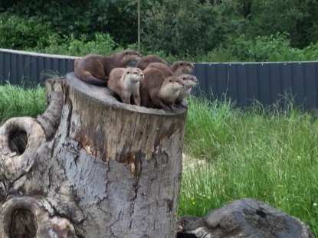
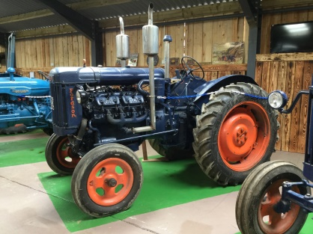
This week has been no exception; the children had an awesome visit to Northumberland Country Zoo on Monday. The children enjoyed 2 workshops and impressed their host zoo keeper for the day with their knowledge of the animal kingdom and their sensible questions.
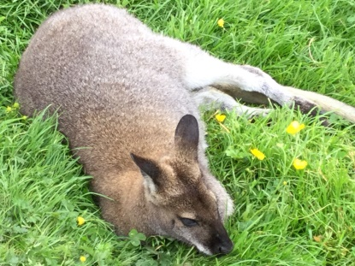
Some of the highlights for the children were the talk in the Bird of Prey area where they got to stroke the resident tawny owl and saw the otters being fed. The children were very well behaved and respectful of the zoo and their rules for behaviour around the animals.

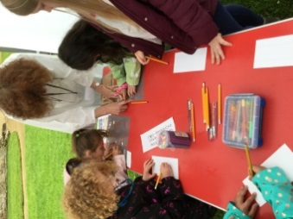

Year 3 and 4 children had an inspirational day at Brinkburn Priory at the Lifepath event on Tuesday. They enjoyed a variety of activities both indoors and outdoors.

We are pleased to welcome Mrs Ford back as Acting Headteacher until the end of this term.
She will be in school at various times over the next few weeks and hopes to say hello to you during this time.

We are looking forward to seeing you all at the events we have planned - we hope the weather stays kind too!

Yours faithfully,

K. Stephenson
Senior Teacher

PTO for the list of dates

As always any changes or updates will be announced as soon as we are aware of them, please keep an eye on our facebook page and in your child’s book bags.

DATES / UPDATES FOR YOUR DIARIES

DATE | EVENT / ACTIVITY
Friday 28th June | TEACHER TRAINING DAY – this week
Tues 1st July | Years 2, 3 & 4 Music Concert – Parents from these year groups are welcome to come along and join us for this performance at 2.30pm
Wed 3rd July | 2.30pm Opportunity for parents to look at pupil books to see their progress over the year
Thurs 4th July | Transition Day @ Tritlington – Nursery pupils who will be Reception in September are invited to stay for the whole day – All other year groups move up into their September year groups and meet their new teachers.
Thurs 4th July | Year 4 day 1 Transition day at Chantry Middle School – details are on the letter you received from Chantry
Fri 5th July | Year 4 day 2 Transition day at Chantry Middle School – as above
Fri 5th July | Sharing Assembly – as usual 2.55 pm start
Fri 5th July | Leavers Party / Disco – 4pm – 6.00 pm – tickets are on sale now
Monday 8th July--- | Creative week – further details to follow
Fri 12th July | 12.30 pm start Sports Day (weather permitting) followed by the Summer Fair
Mon 15th July | Whole School Forest School Day – Please send children to school in old clothes, appropriate footwear for outside / inside, change of clothes / waterproof – in case of inclement weather.
Tues 16th July | Year 4 - Leavers Meal in Morpeth – further details sent separately
Thurs 18th July | School will be closed due to being used as a Polling Station
Fri 19th July | 9am Leavers Service in St. Cuthberts Church, Hebron – Please meet us at Church for the Service and refreshments afterwards at school
Fri 19th July | Break up for Summer Holidays
 | SUMMER HOLIDAYS
Tuesday 3rd September 2019 | School re-opens

