DATE | SUBJECT | YEARS APPLIED TO | REFERENCE | REPLY YES/NO
02.04.2020 | Letter to Children | EVERYONE | SPRING16 | NO

Dear Children

We hope you are enjoying time with your parents, having fun with your family and learning together using your Home Learning Packs and your online lessons in Tapestry and Google Classroom. Lots of your parents have told us that you are happy with your learning activities and you have loved sharing them with your adults. Don’t worry too much if you are struggling to get into a daily routine, just relax, play and read together as much as you can while you get used to these new circumstances. Your teachers are thinking about you everyday and know that you will be learning new skills to share when we come back.

Sharing your Learning

We would love to share with others the amazing home learning you have been doing! Ask your parents if they will help you upload photographs of your learning/outdoor projects onto our Facebook page or school website (just send work to the school office and tell us where you would like it to go) so we can all share and celebrate your learning. By doing so your adult is giving school permission to upload your photograph at this time.
If any of you are having problems logging into School 360, Google Classroom or Tapestry, please let us know as soon as possible and we will get it sorted out for you.

Exercise

It’s important to keep exercising and a great way to start the day is to join in with Joe Wick’s daily PE lesson which can be found on YouTube. It really does wake you up and energise you for the day ahead, as well as being lots of fun! Did you know that Joe donates all the money made from his daily workouts for resources for the NHS. We think this is fantastic and it motivates all of the teachers to join in too!

Reading

Read, read, read...at Tritlington we just love to read! You will find lots of amazing books to read daily on the Oxford Owl website.
If you haven’t checked out the free online books at Oxford Owl, it’s worth a look. Parents there is no sign up https://home.oxfordowl.co.uk/

Making the most of this time

Here are some ideas for activities which you can try at home, to help stay strong physically and mentally, be creative, perhaps trying something new or adventurous.
- Make a den in the garden. Hunt in the garden for interesting things to put in your den
- Form your own band. Look for objects around the house that would make good instruments or make your own!
- Let your creative side go wild and use some recycled materials to make something amazing.
- Go on a treasure hunt, nature hunt or bug hunt - how many bugs can you find?
- Can you help with the preparation for lunch or tea? Do some baking, make some delicious Easter treats and then have fun sharing and eating them.
- Sow some seeds - now is the time to get started in the garden. Do some weeding or just help to tidy up the garden, I’m sure your adults will appreciate your help.

Emotional Support

This is a strange time for you all and there is a useful guide to Corona Virus for you at the following link: https://www.childrenscommissioner.gov.uk/wp-content/uploads/2020/03/cco-childrens-guide-to-coronavirus.pdf
For the time being, just relax, have fun with your family as you get used to this new way of working. Sing and dance together, play games, make lunch, help out around the house and if you have a garden get outside to play as much as you can.

Easter

We will miss our Easter service in church and all our Easter events that we had planned for you but I’m sure you and your adults will have a fun-filled time at Easter anyway.
I am sure the Easter bunny will still pay you a visit, perhaps you could ask an adult to help you make some dyed eggs, decorate an egg or organise an egg hunt in the house or garden.
We wish all our children a very Happy Easter and we are looking forward to seeing all of you again soon. Have fun and stay safe at home.

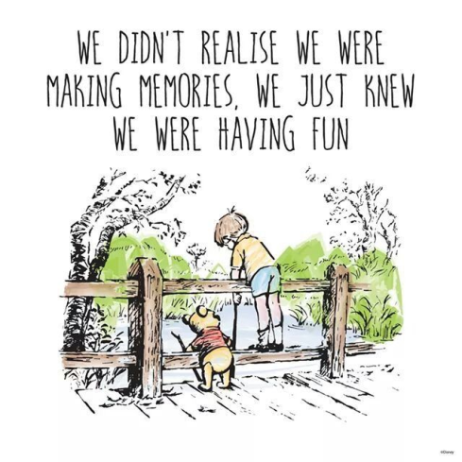

Sending our love
Mrs Stephenson, Mrs O’ Dell, Mrs Gray, all the other teachers and staff at school

