
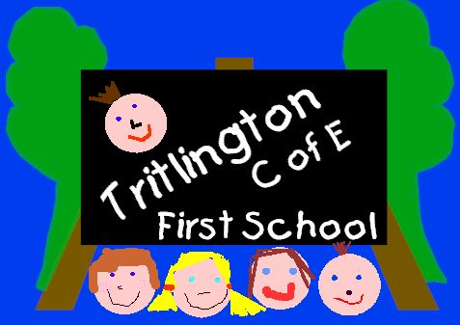



TRITLINGTON CHURCH OF ENGLAND AIDED FIRST SCHOOL
TRITLINGTON, MORPETH, NORTHUMBERLAND NE61 3DU
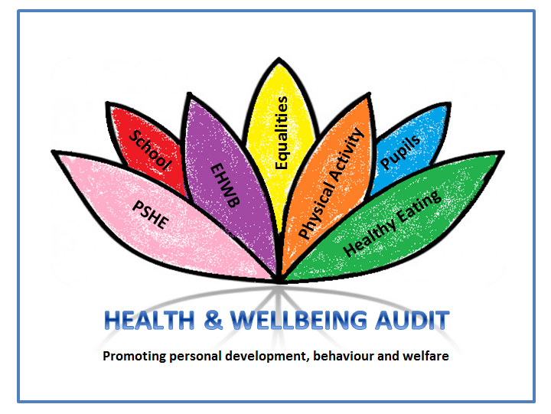

 - 01670 787383 FAX - 01670 783108

Headteacher - Mrs C. H. Hughes B.A. (Hons)

22nd May 2019
Dear Parent / Carer

Ofsted Inspection

We are writing to let you know our Ofsted report is now available following the inspection of 24th and 25th April 2019 and can be viewed on our website from Wednesday 22nd May 2019 - www.tritlington.northumberland.sch.uk/website.

The outcome of this inspection is a 'requires improvement' grade.

We are hosting a Parents Focus Group on Monday 10th June at 2.30pm to present the Revised Action Plan that we are currently working on. Due to half term and various other commitments already in the school calendar this is the earliest that we will have this information ready to share with you.

We were very proud of the manner in which the children conducted themselves during the Inspection; they were articulate and confident in expressing themselves to the Inspector. We are pleased to see that the hard work in Early Years has been recognised, and that we continue to be graded 'good' for Personal Development, Behaviour and Welfare.

While we are disappointed that we have not achieved the 'good' grading that we were aiming for following the last inspection we are pleased that Ofsted recognised that the school has the following strengths;
- support from the local authority and strong leadership from the Early Years leader has resulted in highly effective Early Years provision
- in Early Years children’s progress has improved and is now securely good
- increasing proportions of children are now exceeding the good level of development expected of them by the time they leave Reception
- Behaviour in school is good
- The values of the church are lived out in the relationships that children have with one another. They care about each other and there is a strong family ethos
- Phonics and the teaching of reading in Key stage 1 has improved since the last inspection and is now a strength of the school
- Governors are highly motivated and committed to the school and determined to raise pupils’ outcomes.

What happens next?
A school that has been judged as ‘requires improvement’ will be subject to monitoring by Ofsted in approximately a year. The school will normally have a full Ofsted re-inspection within a period of two years and we are confident that we will have achieved all of the recommendations in that time. We shall keep you informed of our progress and will continue to ask for your views as part of the evaluation of our work.

The governing body and the staff of Tritlington first School recognise and appreciate the support that parents / carers give to the school and it is imperative that we work in partnership to achieve the recognition of ‘good’ and ‘outstanding’ that our school aspires to become.

Yours sincerely

Lynsey Crofts, (Chair of Governors) Helen Hughes (Head Teacher)

e-mail address:-admin@tritlington.northumberland.sch.uk
Web-site:- www.tritlington.northumberland.sch.uk/website





REPLY SLIP OFSTED REPORT April 2019

Name of child:………………………………………………………..

I would like a paper copy of the Ofsted Report sent home with my child.

Signed:……………………………………………………………..Dated:………………………………

PLEASE PRINT YOUR NAME:…………………………………………………………………………

REPLY SLIP OFSTED REPORT April 2019

Name of child:………………………………………………………..

I would like a paper copy of the Ofsted Report sent home with my child.

Signed:……………………………………………………………..Dated:………………………………

PLEASE PRINT YOUR NAME:…………………………………………………………………………

REPLY SLIP OFSTED REPORT April 2019

Name of child:………………………………………………………..

I would like a paper copy of the Ofsted Report sent home with my child.

Signed:……………………………………………………………..Dated:………………………………

PLEASE PRINT YOUR NAME:…………………………………………………………………………

