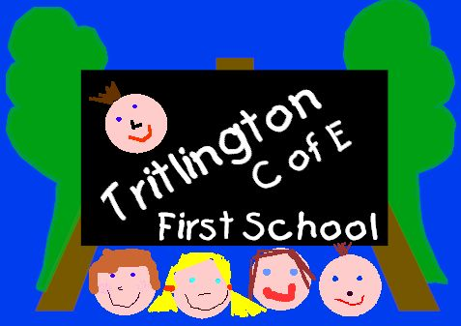

**Tritlington Friends**

**Summer Raffle July 2019**

**Back by popular demand Tritlington Friends have organised their famous Summer Raffle…….lots of prizes to be won!!!!!!**

**PLEASE NOTE ----The draw will take place on the afternoon**

**of Friday 12th July 2019……in the school hall at the Fair.**

**We would ask for your help in the sale of raffle tickets. Attached please find 5 books of tickets to sell to family, friends and neighbours.**

**Tickets are 20p each, or a book of 5 for £1.00.**

**Additional Tickets are available from Mrs. Gray.**

**Please return any unsold tickets and all ticket stubs with the correct money in an envelope via the yellow box by**

**Wednesday 10th July 2019 or sooner if possible.**

**(please also make sure that all stubs are filled in correctly with the person’s name and telephone number and folded into quarters).**

**Thanks in advance for your support.**

**Sarah Welsh - Chair of Tritlington Friends**

**C:\Program Files (x86)\Microsoft Office\MEDIA\CAGCAT10\j0088542.wmf**